Assessment – 2
Name: Ibrar Ahmed

Hands on 28-11-2024
1. Create React App and do the following use props
Create an object named carInfo and send it to the Car component:
2. Create a react App and give form with textbox and checkbox – use functional components

Answer 1:

Car.js as a component
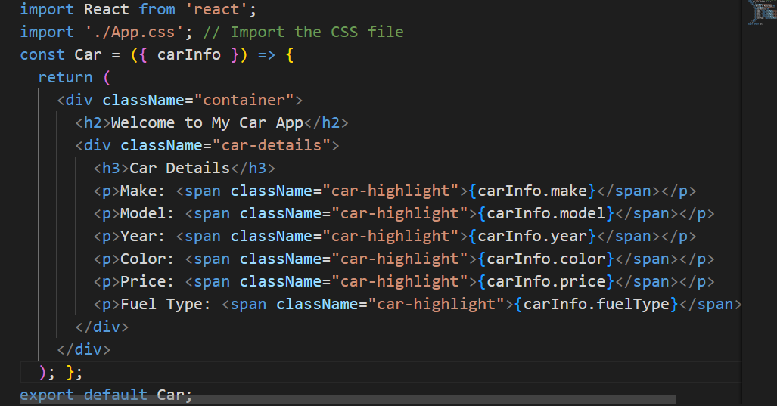

App.js
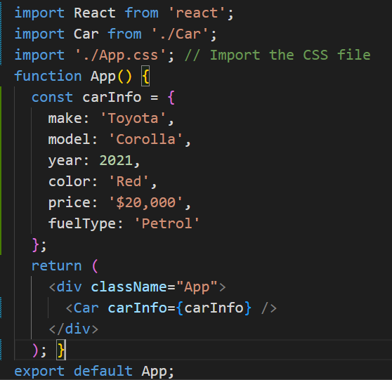

App.css
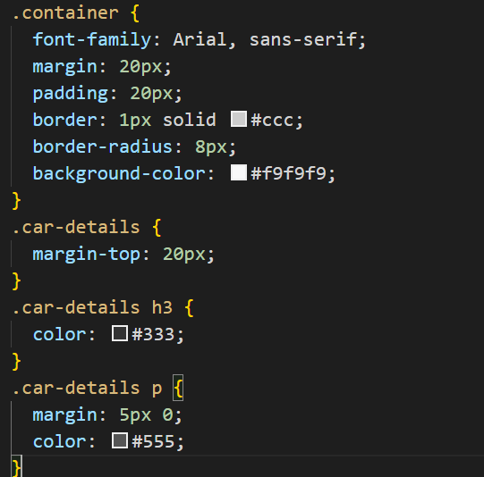

Expected Output:
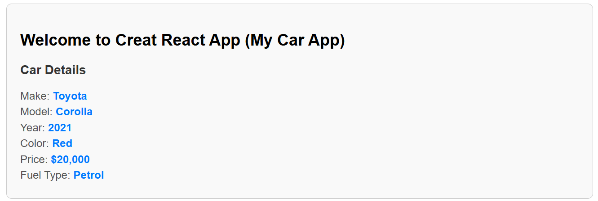
Answer 2:
FormCompone.js
import React, { useState } from 'react';
import './FormComponent.css'; // For custom styling
const FormComponent = () => {
const [formData, setFormData] = useState({
name: '',
agreeToTerms: false,
gender: '',
category: '',
description: '',
});
const handleInputChange = (e) => {
const { name, value, type, checked } = e.target;
setFormData({
...formData,
[name]: type === 'checkbox' ? checked : value,
});
};
const handleSubmit = (e) => {
e.preventDefault();
alert(JSON.stringify(formData, null, 2));
};
return (
<div className="form-container">
<h2>Enhanced Form</h2>
<form onSubmit={handleSubmit}>
{/* Textbox */}
<div className="form-group">
<label htmlFor="name">Name:</label>
<input
type="text"
id="name"
name="name"
value={formData.name}
onChange={handleInputChange}
placeholder="Enter your name"
required
/>
</div>
{/* Radio Buttons */}
<div className="form-group">
<label>Gender:</label>
<label>
<input
type="radio"
name="gender"
value="Male"
checked={formData.gender === 'Male'}
onChange={handleInputChange}
/>
Male
</label>
<label>
<input
type="radio"
name="gender"
value="Female"
checked={formData.gender === 'Female'}
onChange={handleInputChange}
/>
Female
</label>
</div>
{/* Dropdown */}
<div className="form-group">
<label htmlFor="category">Category:</label>
<select
id="category"
name="category"
value={formData.category}
onChange={handleInputChange}
>
<option value="">Select a category</option>
<option value="Student">Student</option>
<option value="Professional">Professional</option>
<option value="Other">Other</option>
</select>
</div>
{/* Text Area */}
<div className="form-group">
<label htmlFor="description">Description:</label>
<textarea
id="description"
name="description"
value={formData.description}
onChange={handleInputChange}
placeholder="Enter a description"
/>
</div>
{/* Checkbox */}
<div className="form-group">
<label>
<input
type="checkbox"
name="agreeToTerms"
checked={formData.agreeToTerms}
onChange={handleInputChange}
/>
I agree to the terms and conditions
</label>
</div>
{/* Submit Button */}
<button type="submit">Submit</button>
</form>
{/* Display Preview */}
<div className="form-preview">
<h3>Preview</h3>
<p><strong>Name:</strong> {formData.name}</p>
<p><strong>Gender:</strong> {formData.gender}</p>
<p><strong>Category:</strong> {formData.category}</p>
<p><strong>Description:</strong> {formData.description}</p>
<p>
<strong>Agree to Terms:</strong> {formData.agreeToTerms ? 'Yes' : 'No'}
</p>
</div>
</div>
);
};
export default FormComponent;

FormComponenet.css
.form-container {
font-family: Arial, sans-serif;
width: 400px;
margin: auto;
padding: 20px;
border: 1px solid #ccc;
border-radius: 10px;
background: #f9f9f9;
}

.form-group {
margin-bottom: 15px;
}

label {
display: block;
margin-bottom: 5px;
color: #333;
}

input[type="text"],
select,
textarea {
width: 100%;
padding: 8px;
margin-top: 5px;
border: 1px solid #ccc;
border-radius: 4px;
}

textarea {
height: 80px;
}

button {
padding: 10px 15px;
background: #007bff;
color: #fff;
border: none;
border-radius: 5px;
cursor: pointer;
}

button:hover {
background: #0056b3;
}

.form-preview {
margin-top: 20px;
background: #fff;
padding: 10px;
border: 1px solid #ddd;
border-radius: 5px;
}

App.js
import React from 'react';
import './App.css';
import FormComponent from './FormComponent';

function App() {
return (
<div className="App">
<h1>React Form Example</h1>
<FormComponent />
</div>
);
}

export default App;

Output:
